Supplementary Information (SI)

Table SI 1: Explanatory variables used in the QRF algorithm training and prediction.

|  |  |  |
| --- | --- | --- |
| Variable groups (number of explanatory variables) | Variables | Source |
| Climate (7) | Rainfall (annual and total for planting season), temperature at planting season (minimum and maximum), mean relative humidity at planting season, mean evapotranspiration at planting season, solar radiation | https://www.meteo.gov.gh |
| Soil (0 – 30 cm) (21) | pH, organic carbon, total nitrogen, cation exchange capacity, available phosphorus, exchangeable bases (calcium, potassium, magnesium and sodium), sand, silt, clay, bulk density, coarse fragment content, electrical conductivity, zinc, iron, total exchangeable bases, base saturation, root zone water holding capacity, soil type | https://www.csirsoilinfo.org  Author’s database |
| Crop (1) | Genotype | Author’s database |
| Environmental (5) | Slope, NDVI, Agro-ecological zone, terrain wetness index, elevation | Savtchenko et al. (2004), https://www.csirsoilinfo.org |
| Management practices (3) | Application of any organic amendment (e.g. poultry manure, cattle manure), management type, mode of fertilizer application | Author’s database |
| Fertilizer application (3) | Nitrogen, phosphorus, potassium | Author’s database |
|  | |  |

Table SI 2: Physico-chemical properties of topsoil (0 – 20 cm) of the 14 farmer experimental sites within the AEZs.

|  |  |  |  |  |  |  |  |  |  |  |  |  |  |
| --- | --- | --- | --- | --- | --- | --- | --- | --- | --- | --- | --- | --- | --- |
| Experimental sites | AEZ | pH H2O (2:1) | Avail. P (mg kg-1 soil) | Total N (g kg-1  soil) | K+  (cmol+ kg-1  soil) | Ca2+  (cmol+ kg-1 soil) | Mg2+  (cmol+ kg-1) | Na+  (cmol+ kg-1) | ECEC  (cmol+ kg-1) | OC  (g kg-1) | Sand (%) | Clay (%) | Silt  (%) |
| Lawra | GS | 5.6 | 23.4 | 1.010 | 0.257 | 6.600 | 3.013 | 0.069 | 10.560 | 11.4 | 75.3 | 8.6 | 16.1 |
| Jirapa | 5.0 | 16.2 | 1.010 | 0.171 | 2.400 | 1.527 | 0.064 | 4.765 | 9.0 | 73.7 | 9.1 | 17.2 |
| Nahaa | 5.4 | 13.4 | 1.040 | 0.238 | 6.867 | 3.287 | 0.054 | 11.064 | 12.0 | 76.2 | 8.5 | 15.3 |
| Wichau | 5.6 | 13.2 | 1.140 | 0.166 | 2.150 | 1.270 | 0.069 | 4.254 | 10.5 | 74.0 | 8.3 | 17.7 |
| Kyeremfaso Site A | FST | 5.4 | 8.8 | 1.120 | 0.295 | 5.200 | 1.840 | 0.059 | 8.045 | 13.7 | 79.4 | 9.0 | 11.6 |
| Kyeremfaso Site B | 5.4 | 7.6 | 1.100 | 0.323 | 4.800 | 1.763 | 0.057 | 7.575 | 12.9 | 80.1 | 9.7 | 10.2 |
| Amantin Site A | 4.4 | 16.1 | 1.050 | 0.328 | 1.480 | 0.920 | 0.067 | 3.407 | 4.7 | 89.4 | 1.0 | 9.6 |
| Amantin Site B | 4.2 | 13.1 | 1.070 | 0.262 | 1.207 | 0.740 | 0.059 | 2.894 | 3.8 | 90.7 | 1.0 | 8.3 |
| Atebubu Site A | 4.6 | 12.3 | 1.190 | 0.105 | 2.000 | 1.240 | 0.055 | 4.058 | 7.2 | 61.4 | 7.0 | 31.6 |
| Atebubu Site B | 4.5 | 12.8 | 1.070 | 0.126 | 1.853 | 1.093 | 0.051 | 3.778 | 7.2 | 60.8 | 7.7 | 31.5 |
| Wioso | SDF | 5.5 | 14.1 | 1.140 | 0.223 | 6.133 | 3.243 | 0.062 | 10.240 | 17.5 | 41.4 | 22.2 | 36.4 |
| Seidi | 5.8 | 7.5 | 1.010 | 0.406 | 7.527 | 3.343 | 0.063 | 11.900 | 8.8 | 44.1 | 19.0 | 36.9 |
| Kokoben | 5.5 | 9.9 | 0.980 | 0.277 | 9.067 | 4.330 | 0.048 | 14.300 | 14.4 | 50.7 | 19.0 | 30.3 |
| Kwadaso | 5.6 | 10.5 | 1.100 | 0.306 | 9.185 | 3.985 | 0.053 | 14.700 | 10.3 | 48.6 | 18.8 | 32.6 |

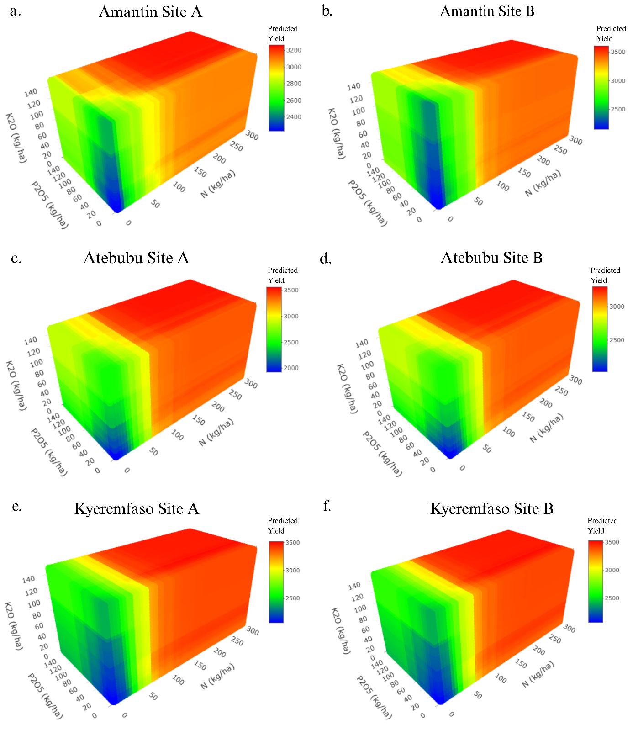

Figure SI 1: Predicted maize yield response to N, P, and K fertilizer application in the FST agroecological zone of Ghana. Panels a–f show 3D response surfaces for predicted maize yield (kg ha⁻¹) across six sites: a) Amantin Site A, b) Amantin Site B, c) Atebubu Site A, d) Atebubu Site B, e) Kyeremfaso Site A, and f) Kyeremfaso Site B. Each plot displays yield responses to varying levels of N, P, and K. Colour gradients indicate yield magnitude, with red representing higher yields and blue indicating lower yields.

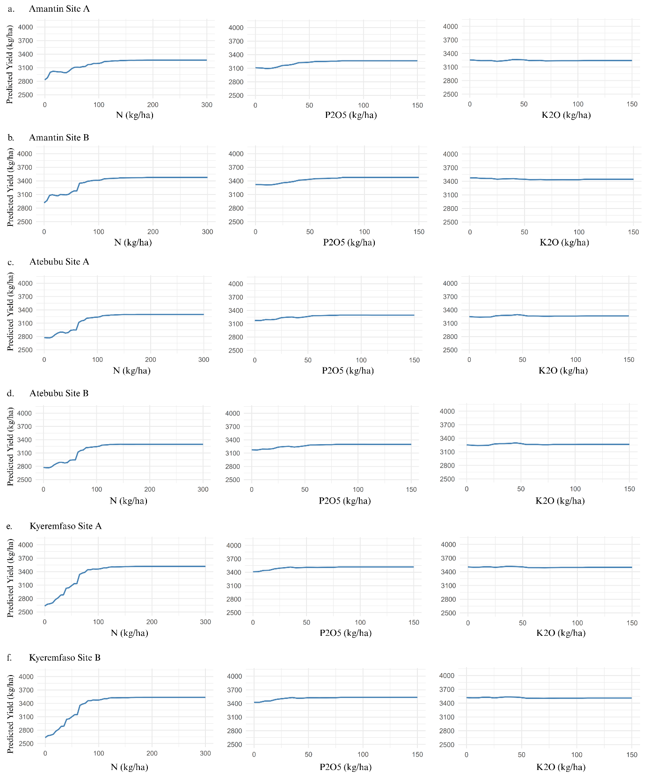

Figure SI 2: Response curves of predicted maize yield to N, P, and K fertilizer applications at six sites in the FST zone of Ghana. Panels a–f corresponds to a different site: a) Amantin Site A, b) Amantin Site B, c) Atebubu Site A, d) Atebubu Site B, e) Kyeremfaso Site A, and f) Kyeremfaso Site B. Within each panel, three subplots illustrate the effect of increasing application rates of: N (left column), P (middle column), K (right column), on predicted maize yield (kg ha⁻¹), while holding the others on the value that produces the highest yield.

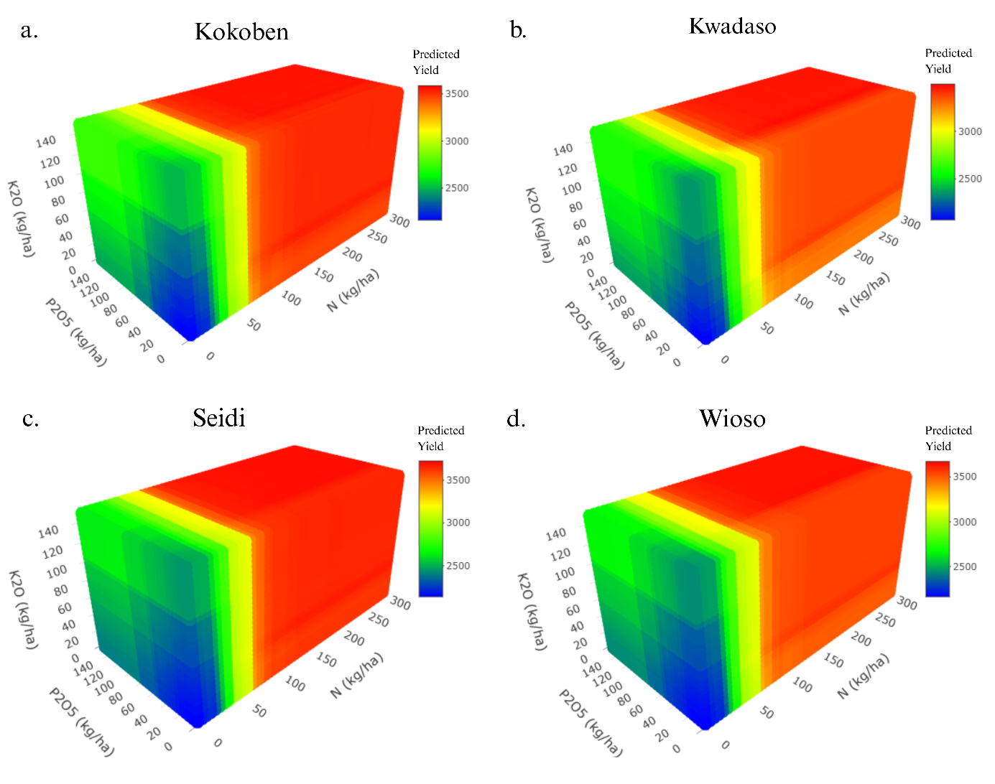

Figure SI 3: Predicted maize yield response to N, P, and K fertilizer application in the SDF agroecological zone of Ghana. Panels a-d show 3D response surfaces for predicted maize yield (kg ha⁻¹) across four sites: a) Kokoben, b) Kwadaso, c) Seidi, and d) Wioso. Each plot displays yield responses to varying levels of N, P, and K. Colour gradients indicate yield magnitude, with red representing higher yields and blue indicating lower yields.

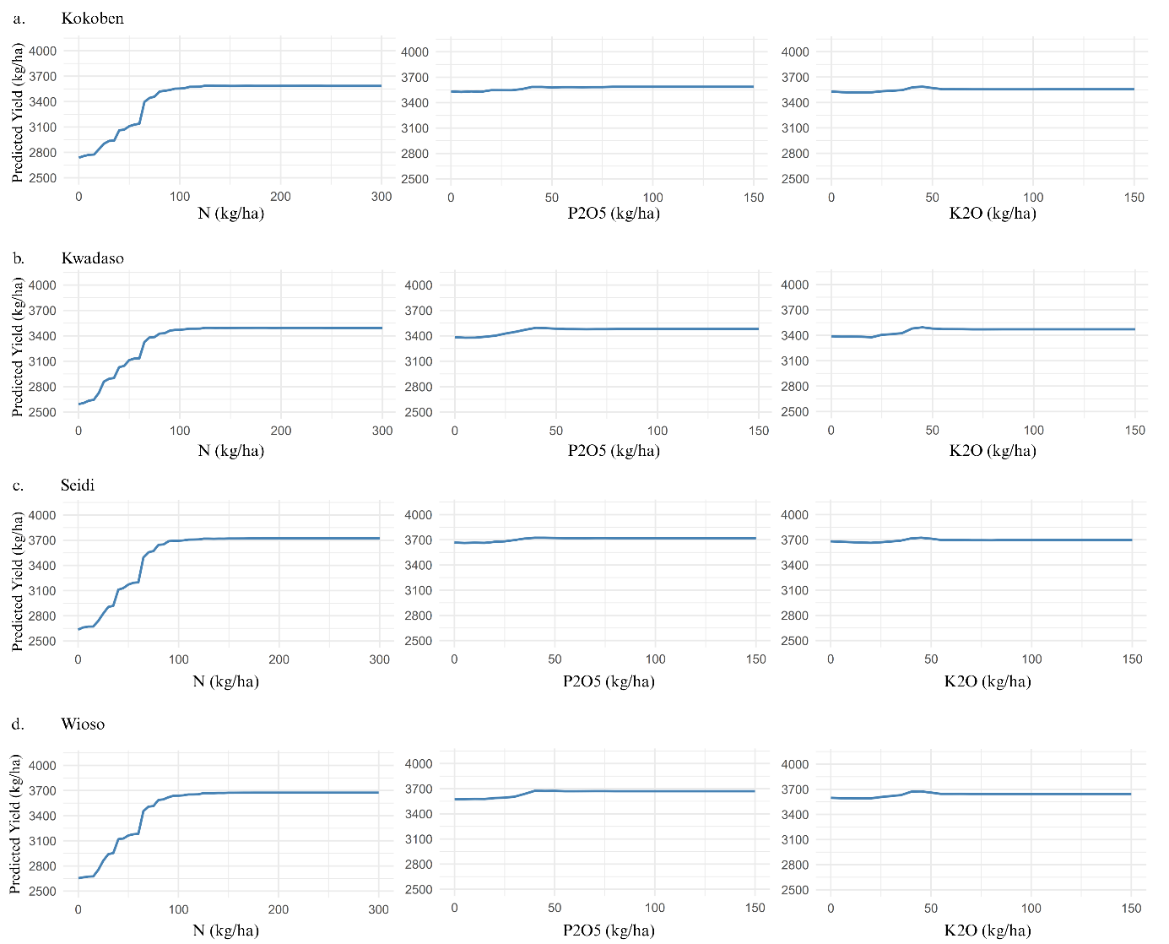

Figure SI 4: Response curves of predicted maize yield to N, P, and K fertilizer applications at six sites in the SDF zone of Ghana. Panels a-d corresponds to a different site: a) Kokoben, b) Kwadaso, c) Seidi, and d) Wioso. Within each panel, three subplots illustrate the effect of increasing application rates of: N (left column), P (middle column), K (right column), on predicted maize yield (kg ha⁻¹), while holding the others on the value that produces the highest yield.

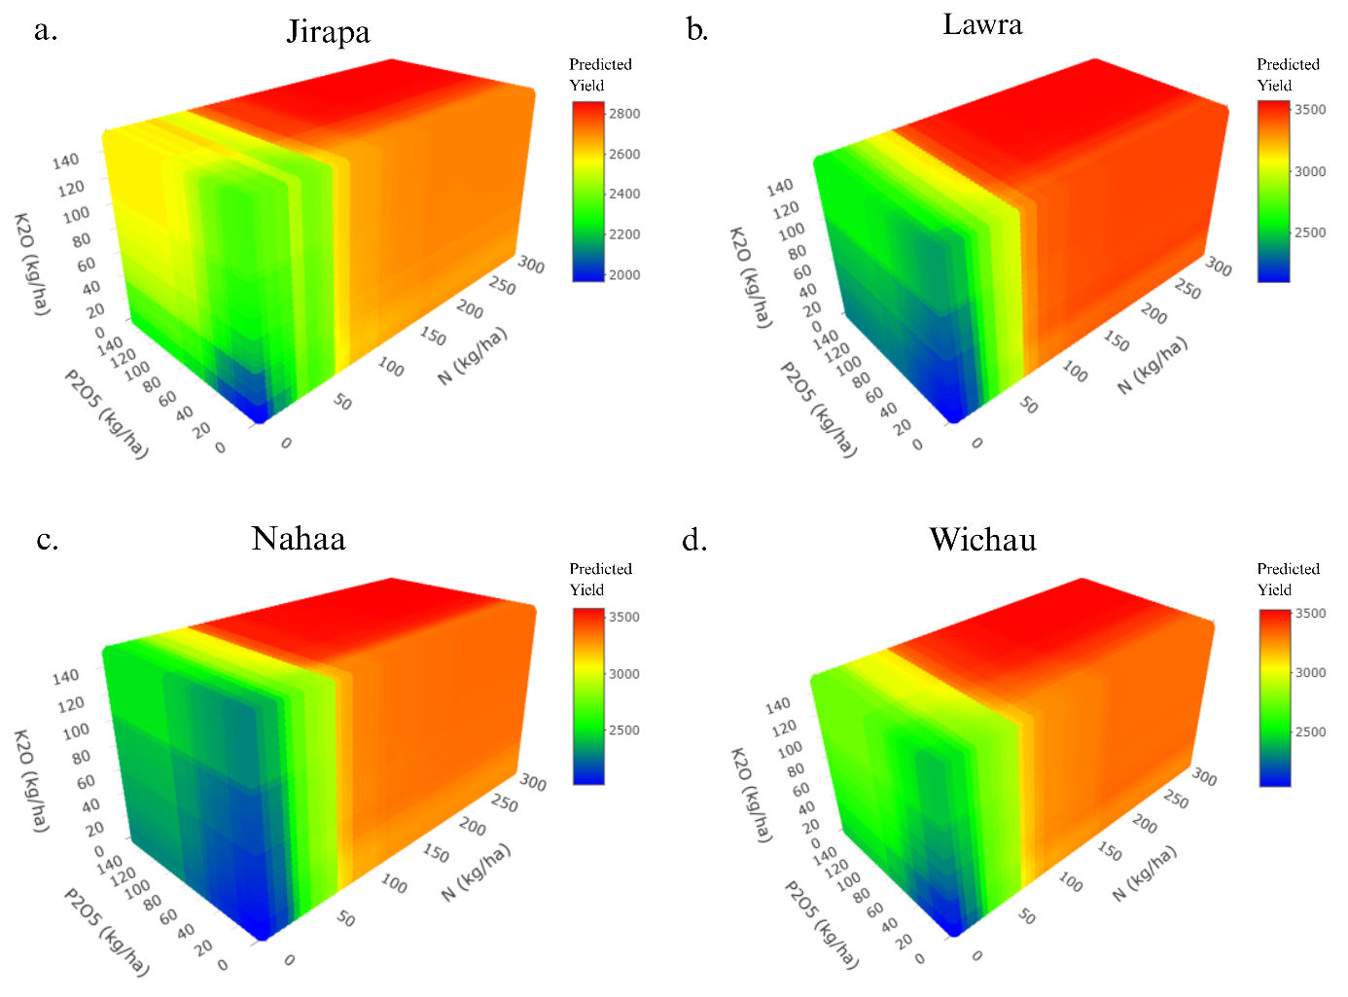

Figure SI 5: Predicted maize yield response to N, P, and K fertilizer application in the GS agroecological zone of Ghana. Panels a–d show 3D response surfaces for predicted maize yield (kg ha⁻¹) across four sites: a) Jirapa, b) Lawra, c) Nahaa, and d) Wichau. Each plot displays yield responses to varying levels of N, P, and K. Colour gradients indicate yield magnitude, with red representing higher yields and blue indicating lower yields.

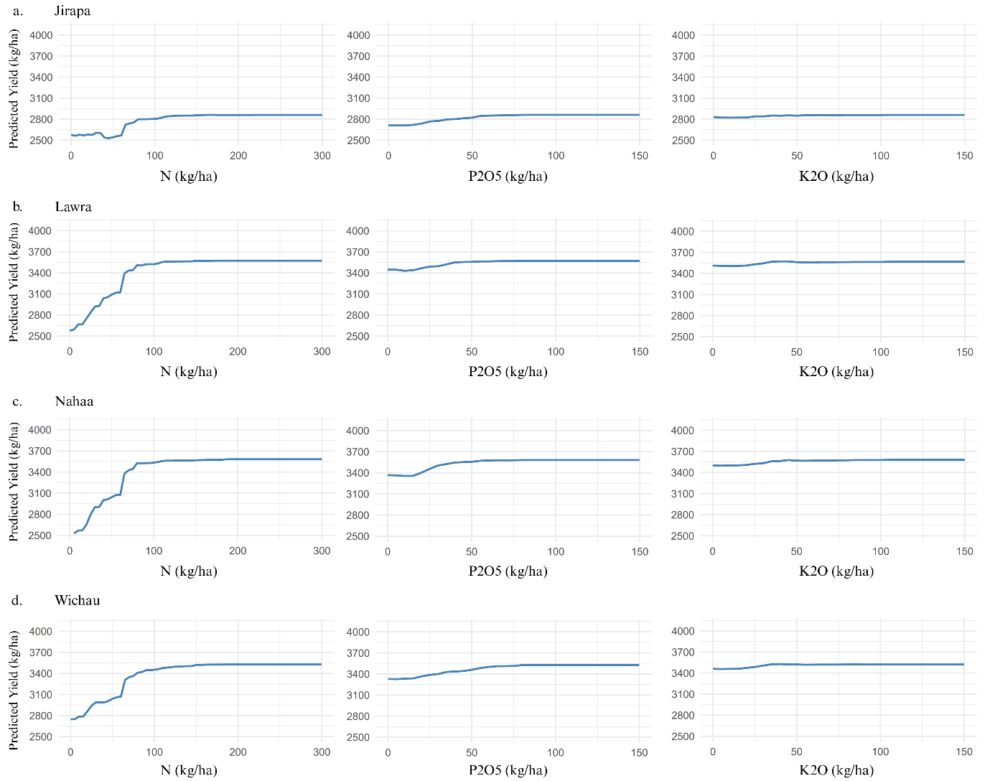

Figure SI 6: Response curves of predicted maize yield to N, P, and K fertilizer applications at six sites in the GS zone of Ghana. Panels a–d corresponds to a different site: a) Jirapa, b) Lawra, c) Nahaa, and d) Wichau. Within each panel, three subplots illustrate the effect of increasing application rates of: N (left column), P (middle column), K (right column), on predicted maize yield (kg ha⁻¹), while holding the others on the value that produces the highest yield.

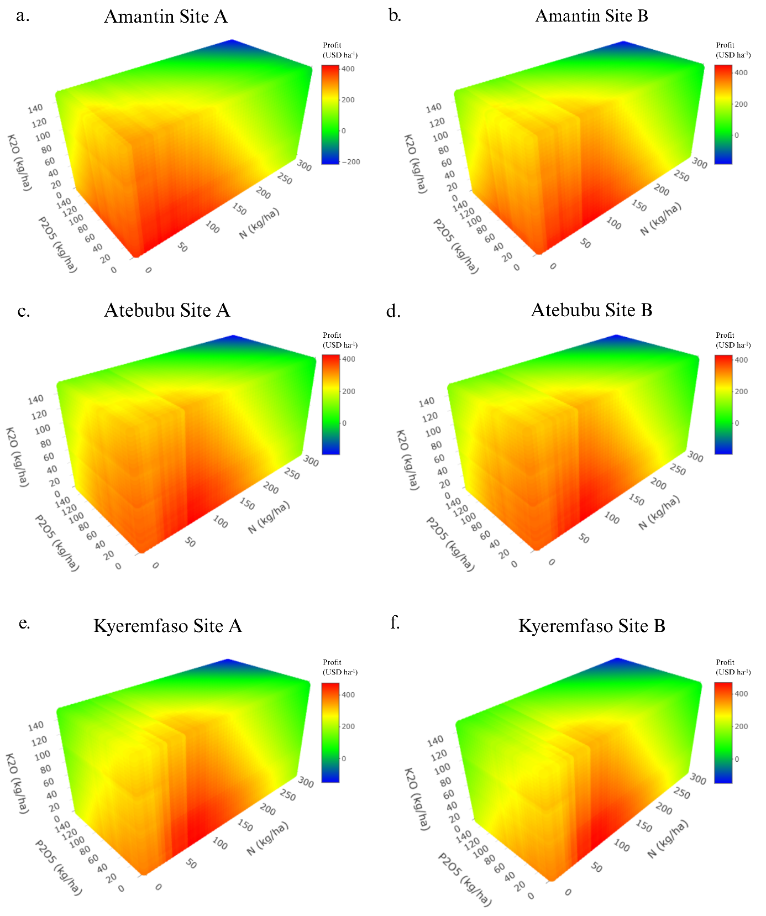

Figure SI 7: Profit response to N, P, and K fertilizer applications at six sites in the FST zone of Ghana. Panels a–f corresponds to a different site: a) Amantin Site A, b) Amantin Site B, c) Atebubu Site A, d) Atebubu Site B, e) Kyeremfaso Site A, and f) Kyeremfaso Site B. Each plot displays profit responses to varying levels of N, P, and K. Colour gradients indicate profit magnitude, with red representing higher profits and blue indicating lower profits.

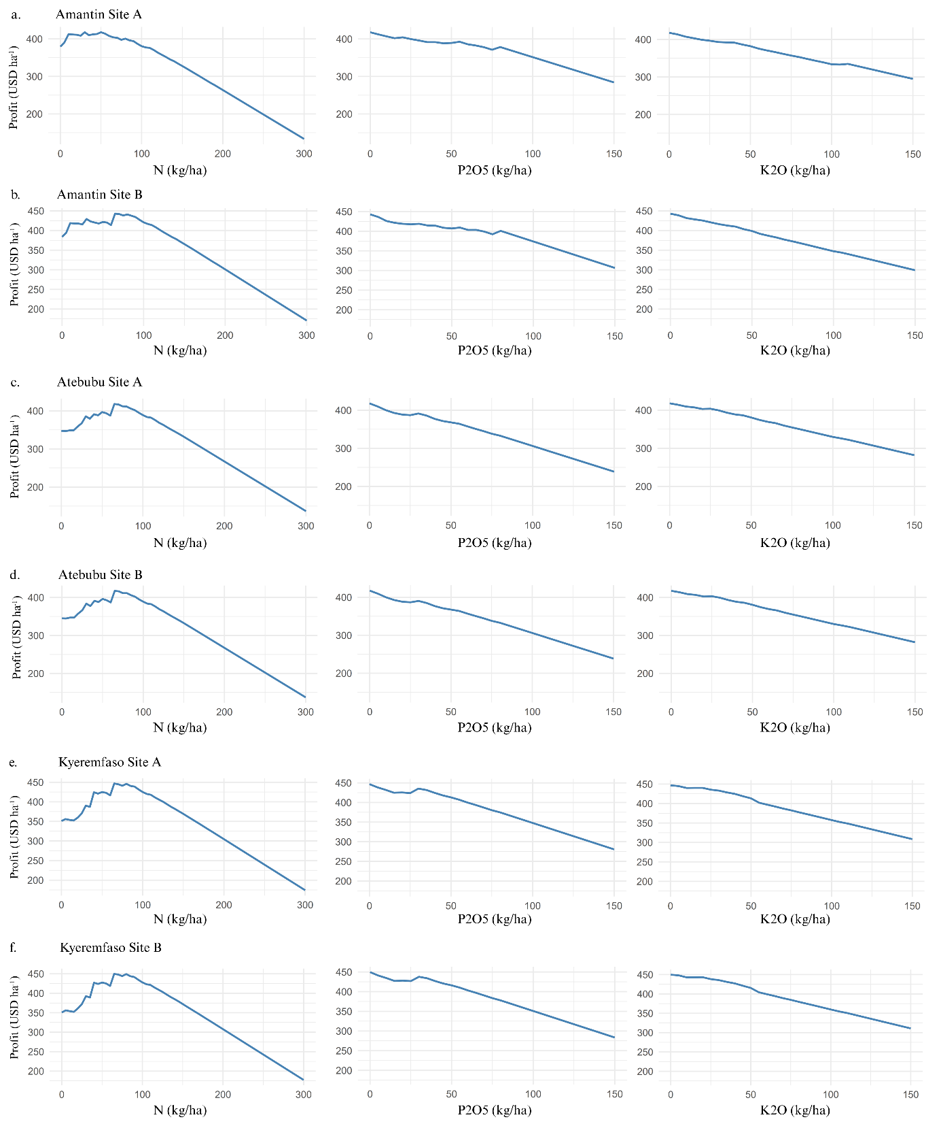

Figure SI 8: Profit response to N, P, and K fertilizer applications at six sites in the FST zone of Ghana. Panels a–f corresponds to a different site: a) Amantin Site A, b) Amantin Site B, c) Atebubu Site A, d) Atebubu Site B, e) Kyeremfaso Site A, and f) Kyeremfaso Site B. Within each panel, three subplots illustrate the effect of increasing application rates of: N (left column), P (middle column), K (right column), on predicted profit (USD ha⁻¹), while holding the others on the value that produces the highest profit.

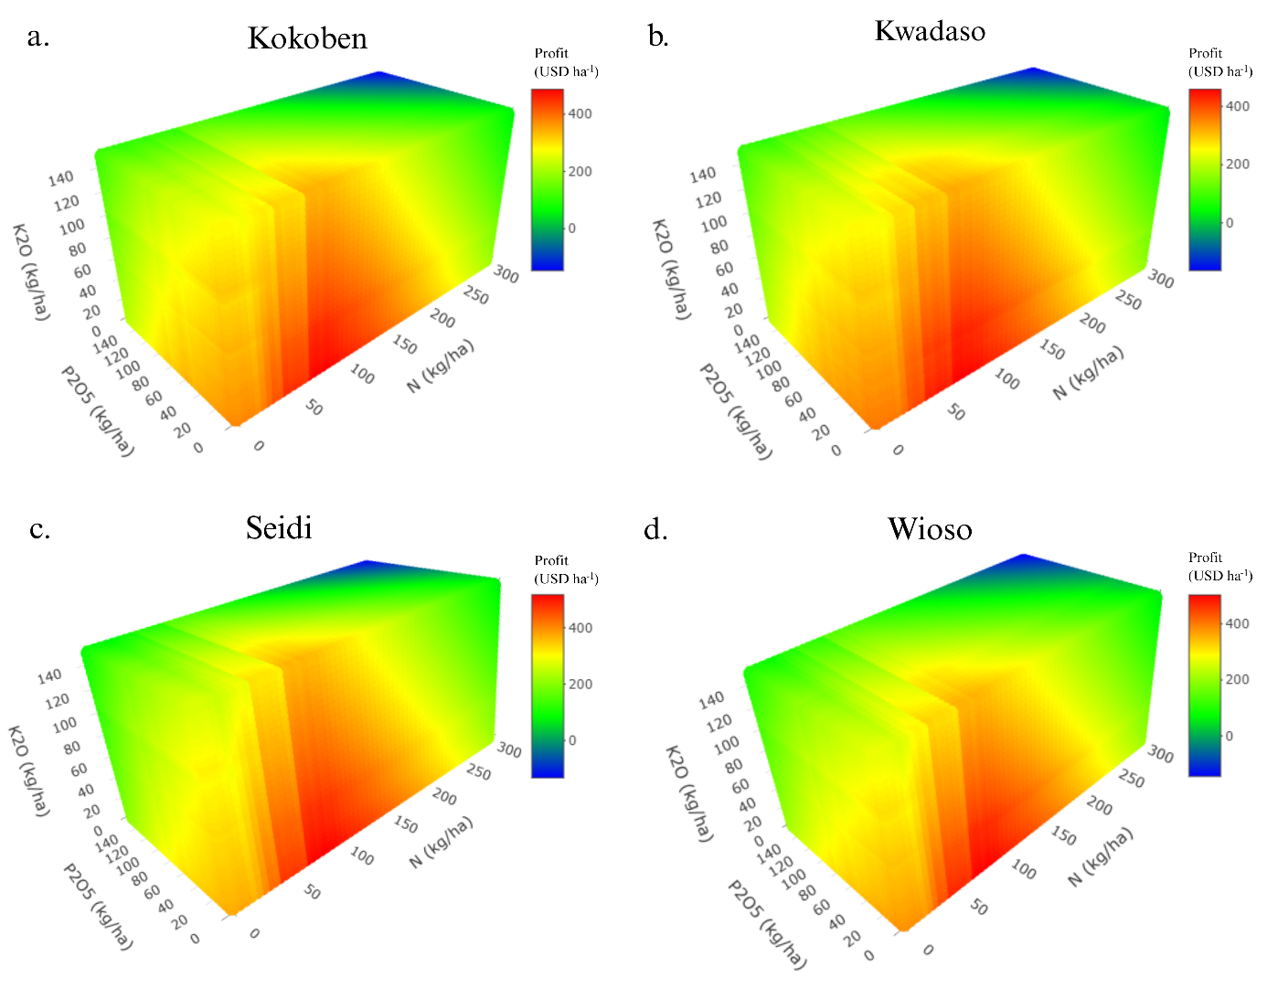

Figure SI 9: Profit response to N, P, and K fertilizer application in the SDF agroecological zone of Ghana. Panels a–d show 3D response surfaces for predicted maize yield (kg ha⁻¹) across four sites: a) Kokoben, b) Kwadaso, c) Seidi, and d) Wioso. Each plot displays profit responses to varying levels of N, P, and K. Colour gradients indicate profit magnitude, with red representing higher profit and blue indicating lower profits.

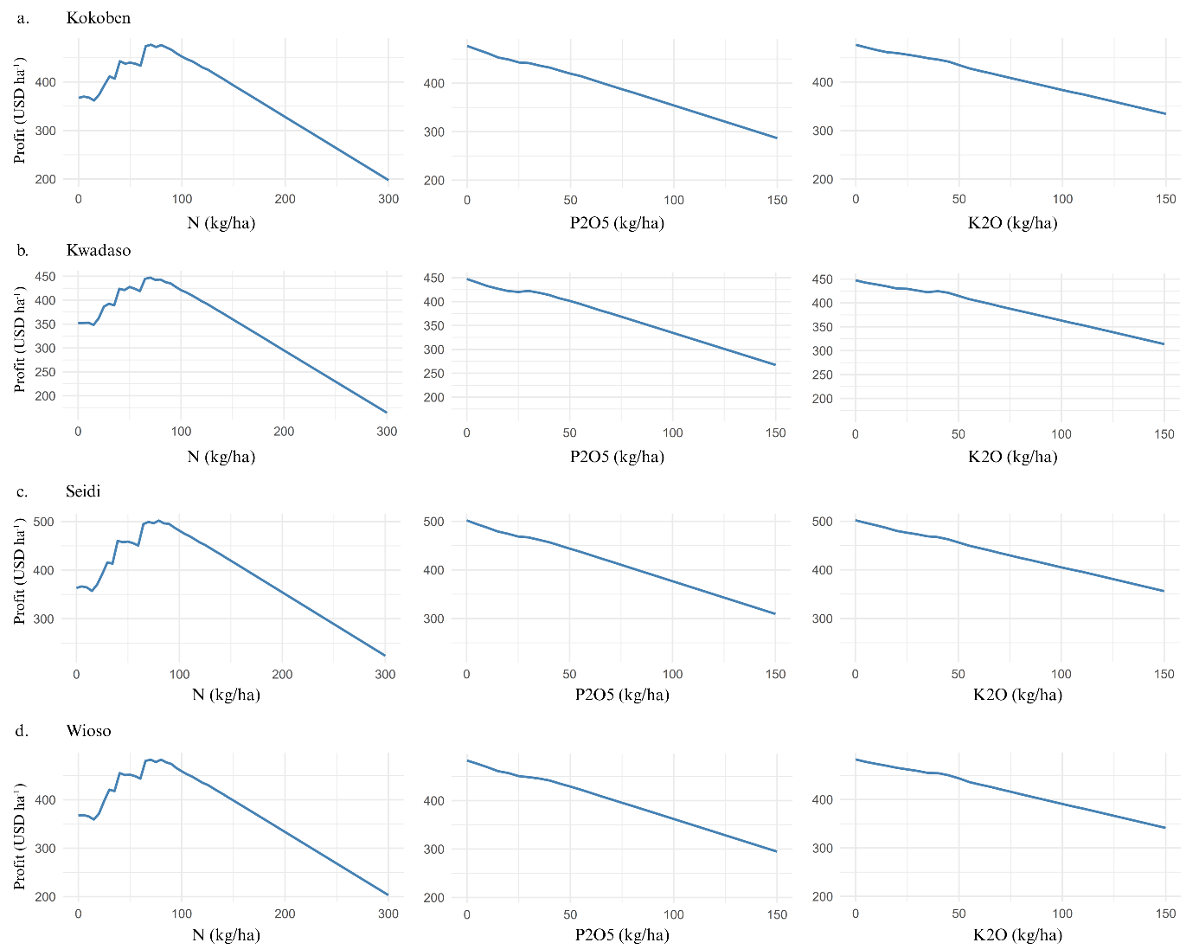

Figure SI 10: Profit response to N, P, and K fertilizer application at six sites in the SDF zone of Ghana. Panels a–d corresponds to a different site: a) Kokoben, b) Kwadaso, c) Seidi, and d) Wioso. Within each panel, three subplots illustrate the effect of increasing application rates of: N (left column), P (middle column), K (right column), on predicted profit (USD ha⁻¹), while holding the others on the value that produces the highest profit.

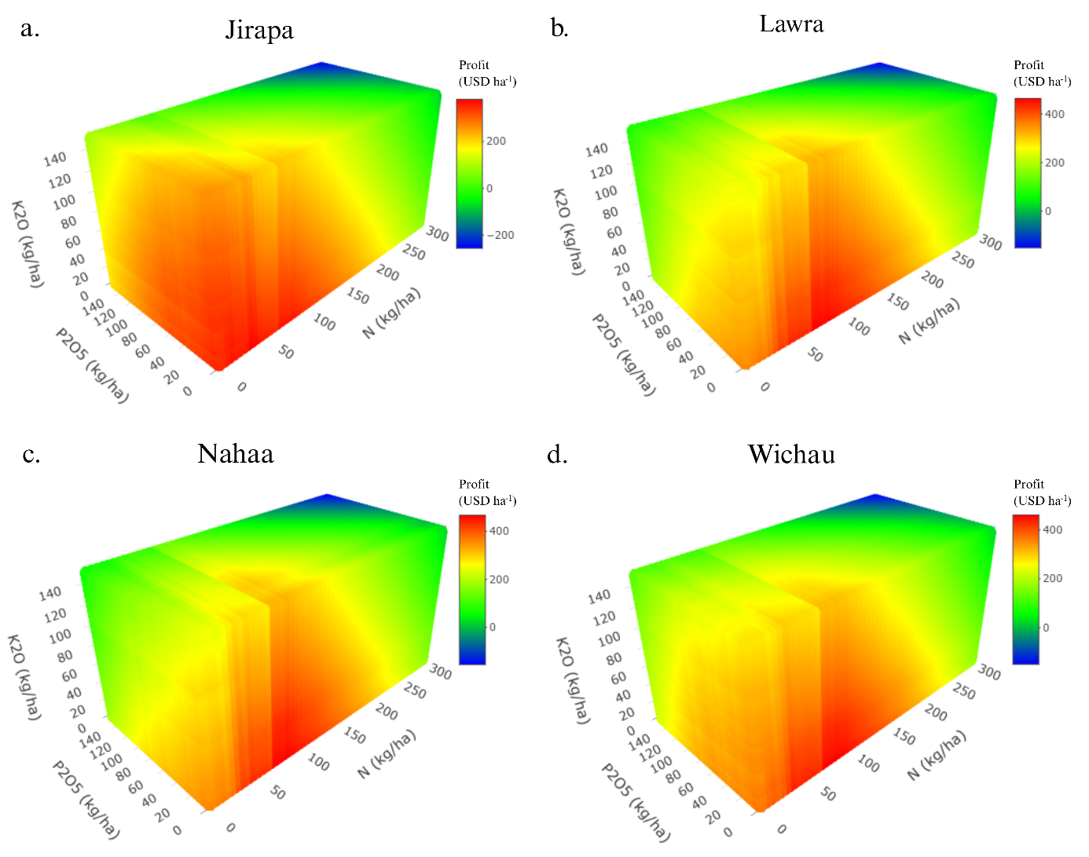

Figure SI 11: Profit response to N, P, and K fertilizer application at six sites in the GS zone of Ghana. Panels a–d corresponds to a different site: a) Jirapa, b) Lawra, c) Nahaa, and d) Wichau. Each plot displays profit responses to varying levels of N, P, and K. Colour gradients indicate profit magnitude, with red representing higher profits and blue indicating lower profits.

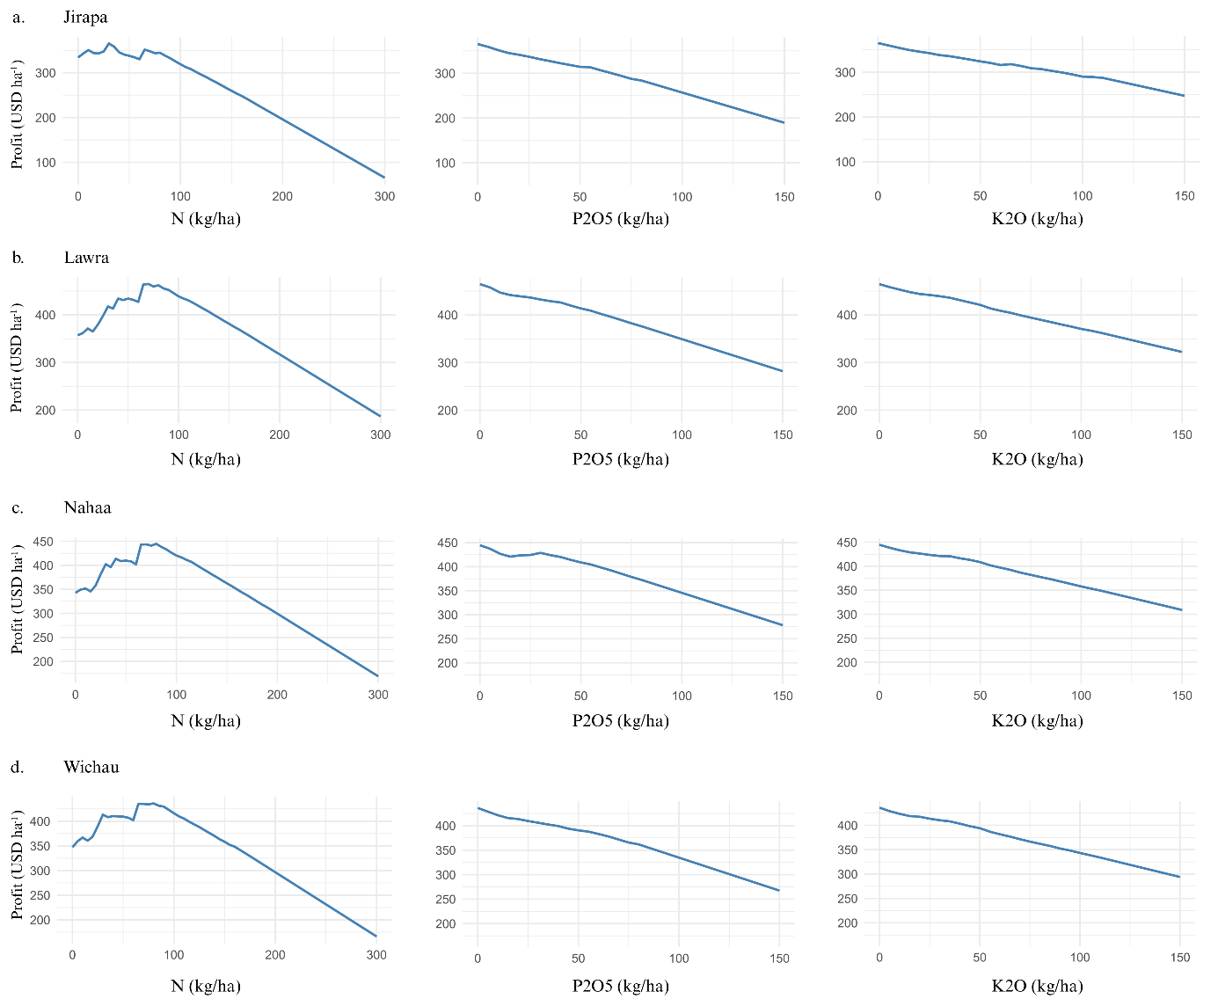

Figure SI 12: Profit response to N, P, and K fertilizer application at six sites in the GS zone of Ghana. Panels a–d corresponds to a different site: a) Jirapa, b) Lawra, c) Nahaa, and d) Wichau. Within each panel, three subplots illustrate the effect of increasing application rates of: N (left column), P (middle column), K (right column), on predicted profit (USD ha⁻¹), while holding the others on the value that produces the highest profit.

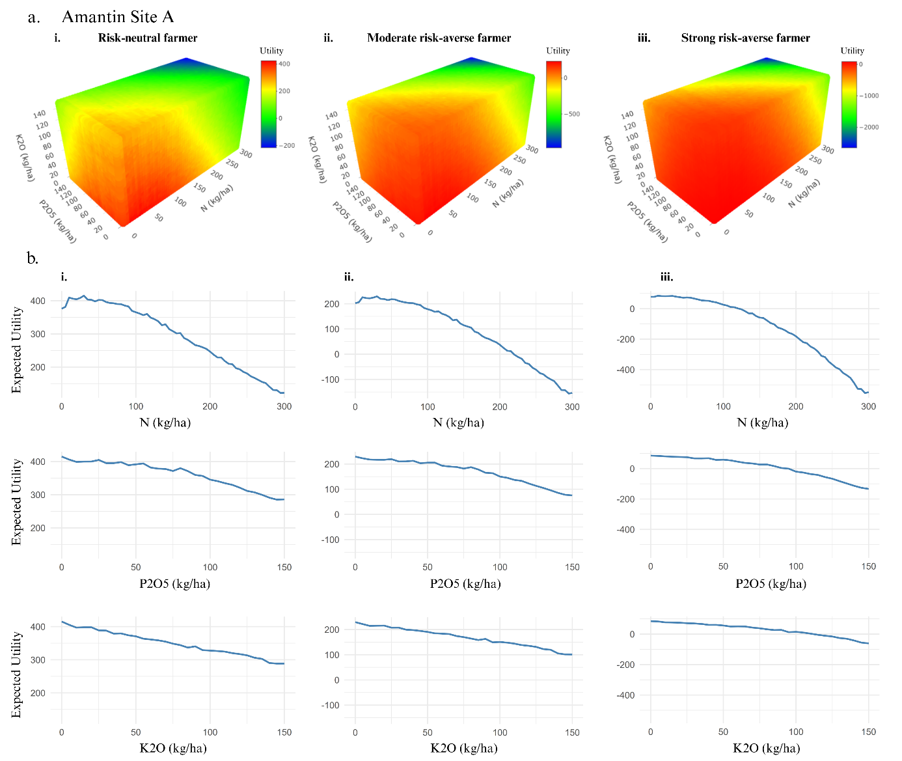

Figure SI 13: Predicted utility response to fertilizer application for different farmer risk preferences at Amantin Site A (FST zone Panel ‘a’ shows three-dimensional utility response surfaces to N, P, and K fertilizer rates for three categories of farmer risk preference: i) Risk-neutral farmer, ii) Moderately risk-averse farmer, iii) Strongly risk-averse farmer. Colour gradients represent the magnitude of utility, with green to red indicating higher to lower utility, and blue denoting negative utility outcomes. Panel ‘b’ presents utility curves for each fertilizer nutrient: Rows represent nutrient types: top = N, middle = P, bottom = K. Columns correspond to the same risk profiles as in Panel ‘a’: i) Risk-neutral, ii) Moderate risk-averse, iii) Strong risk-averse farmers.

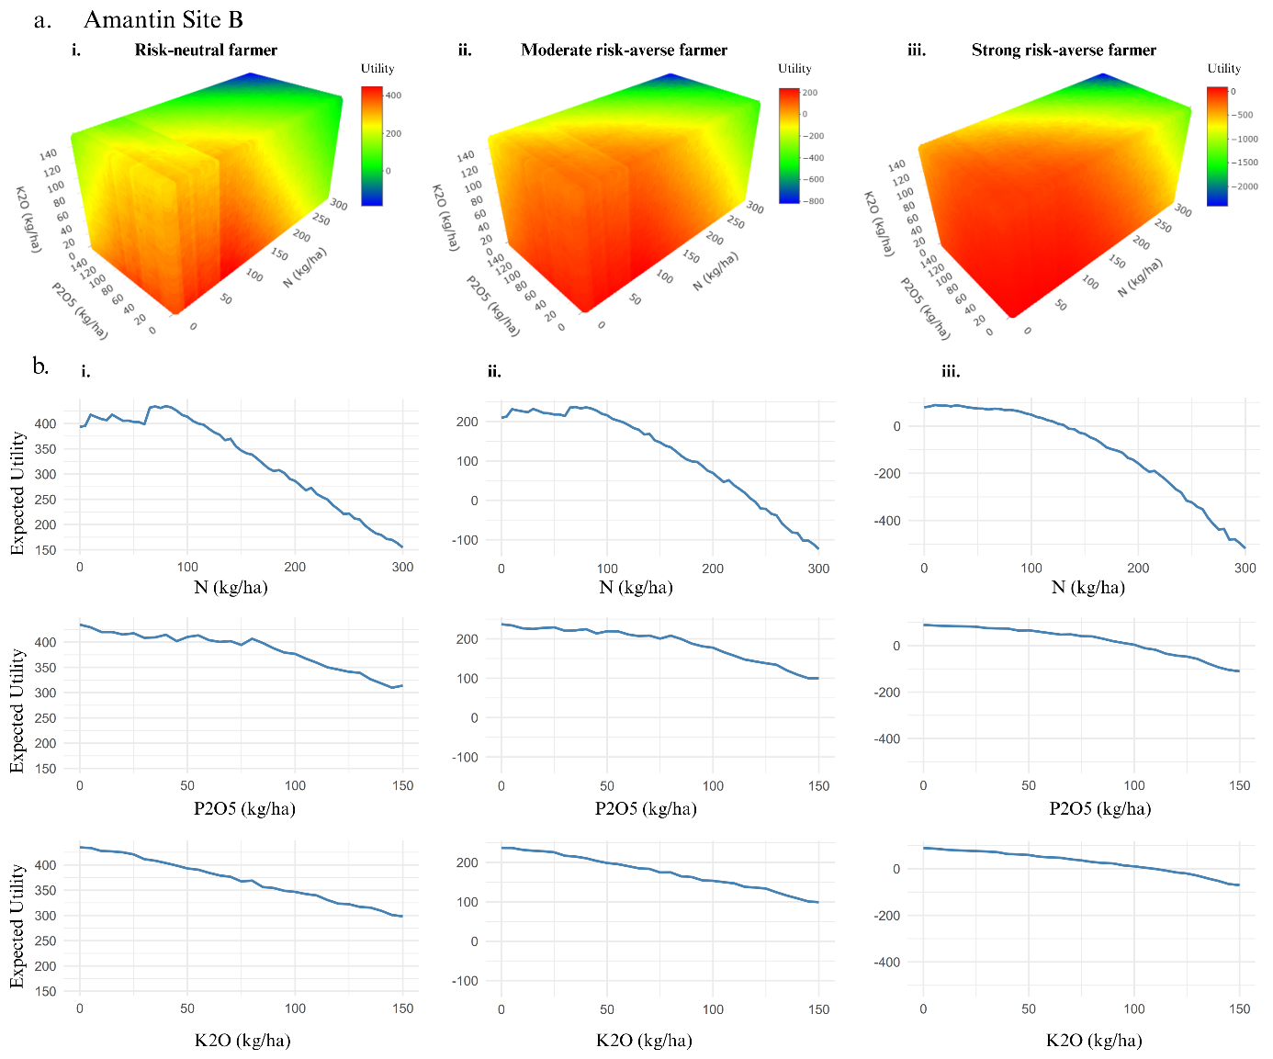

Figure SI 14: Predicted utility response to fertilizer application for different farmer risk preferences at Amantin Site B (FST zone Panel ‘a’ shows three-dimensional utility response surfaces to N, P, and K fertilizer rates for three categories of farmer risk preference: i) Risk-neutral farmer, ii) Moderately risk-averse farmer, iii) Strongly risk-averse farmer. Colour gradients represent the magnitude of utility, with green to red indicating higher to lower utility, and blue denoting negative utility outcomes. Panel ‘b’ presents utility curves for each fertilizer nutrient: Rows represent nutrient types: top = N, middle = P, bottom = K. Columns correspond to the same risk profiles as in Panel ‘a’: i) Risk-neutral, ii) Moderate risk-averse, iii) Strong risk-averse farmers.

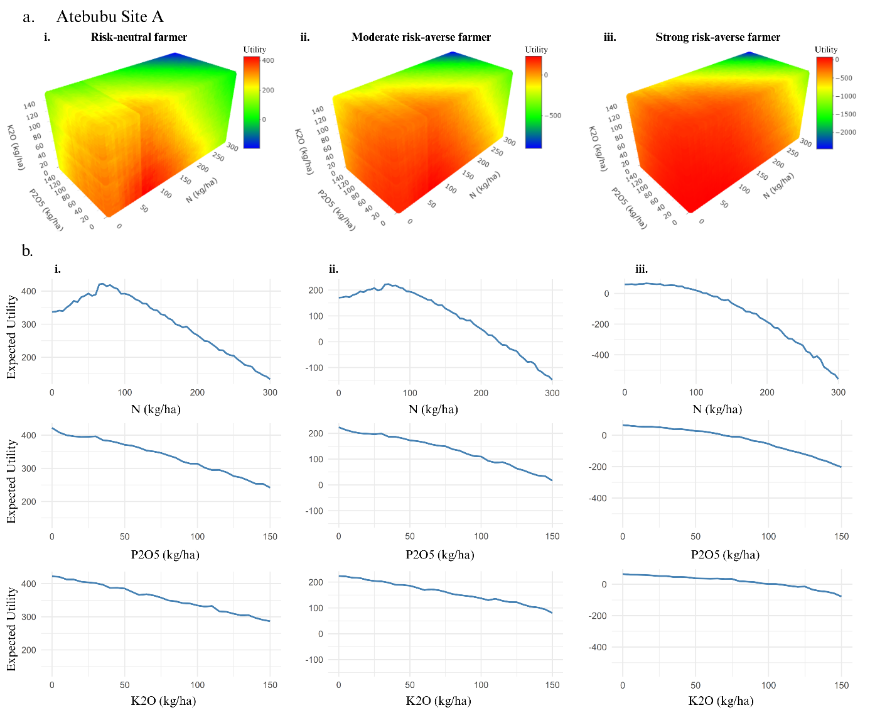

Figure SI 15: Predicted utility response to fertilizer application for different farmer risk preferences at Atebubu Site A (FST zone). Panel ‘a’ shows three-dimensional utility response surfaces to N, P, and K fertilizer rates for three categories of farmer risk preference: i) Risk-neutral farmer, ii) Moderately risk-averse farmer, iii) Strongly risk-averse farmer. Colour gradients represent the magnitude of utility, with green to red indicating higher to lower utility, and blue denoting negative utility outcomes. Panel ‘b’ presents utility curves for each fertilizer nutrient: Rows represent nutrient types: top = N, middle = P, bottom = K. Columns correspond to the same risk profiles as in Panel ‘a’: i) Risk-neutral, ii) Moderate risk-averse, iii) Strong risk-averse farmers.

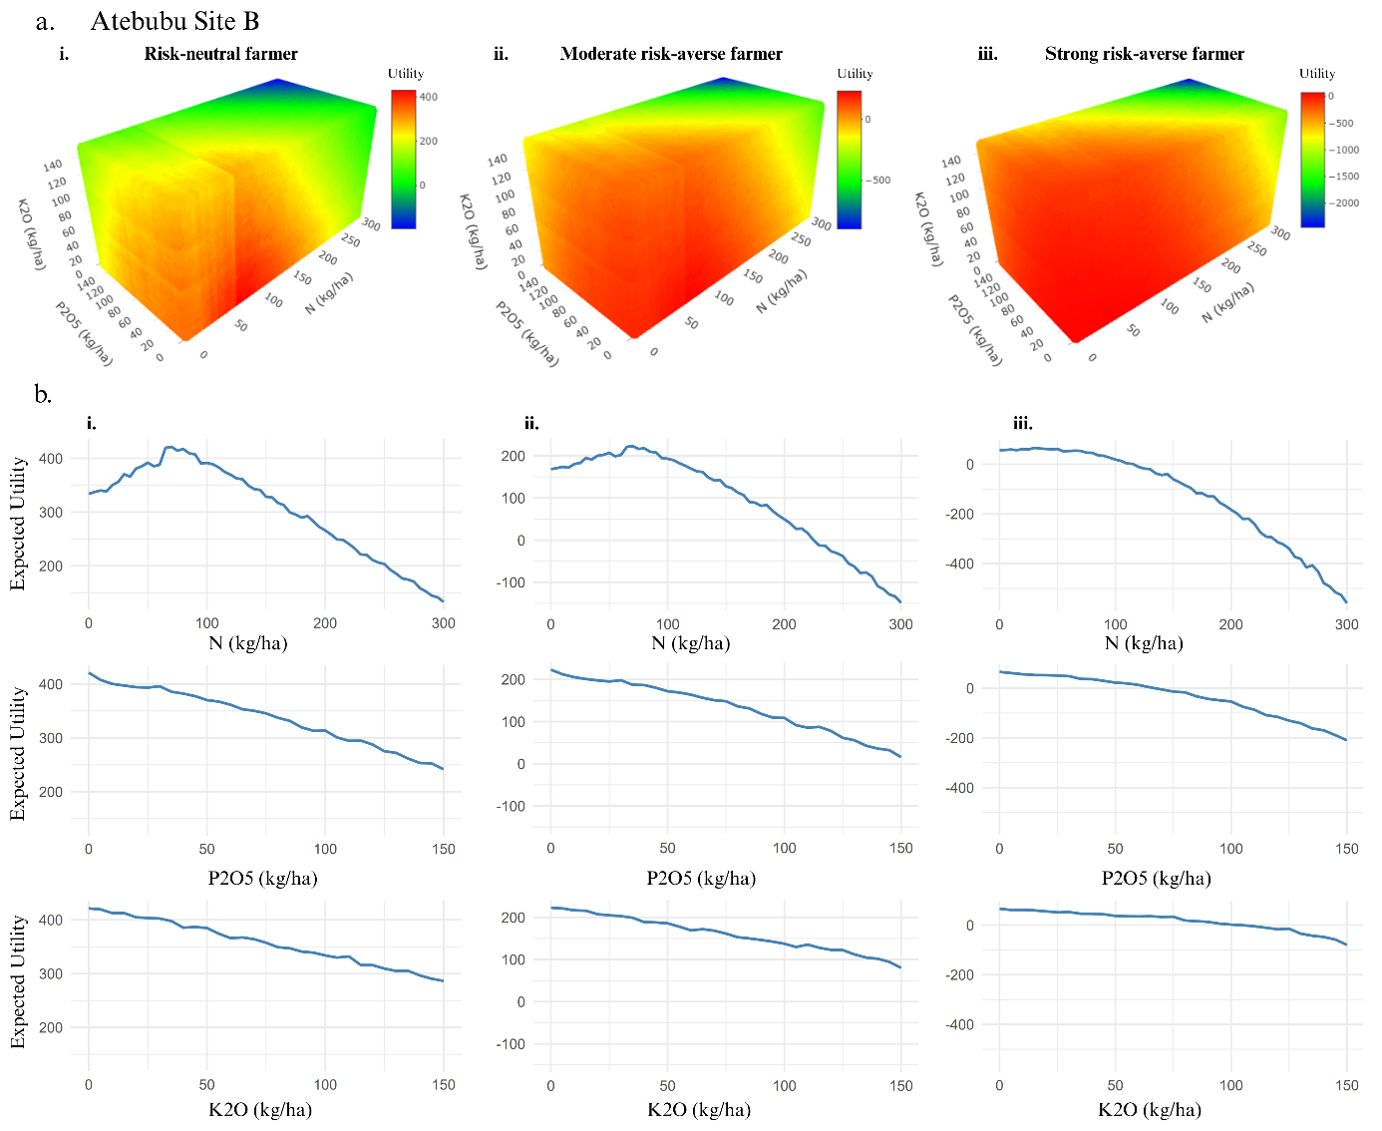

Figure SI 16: Predicted utility response to fertilizer application for different farmer risk preferences at Atebubu Site B (FST zone). Panel ‘a’ shows three-dimensional utility response surfaces to N, P, and K fertilizer rates for three categories of farmer risk preference: i) Risk-neutral farmer, ii) Moderately risk-averse farmer, iii) Strongly risk-averse farmer. Colour gradients represent the magnitude of utility, with green to red indicating higher to lower utility, and blue denoting negative utility outcomes. Panel ‘b’ presents utility curves for each fertilizer nutrient: Rows represent nutrient types: top = N, middle = P, bottom = K. Columns correspond to the same risk profiles as in Panel ‘a’: i) Risk-neutral, ii) Moderate risk-averse, iii) Strong risk-averse farmers.

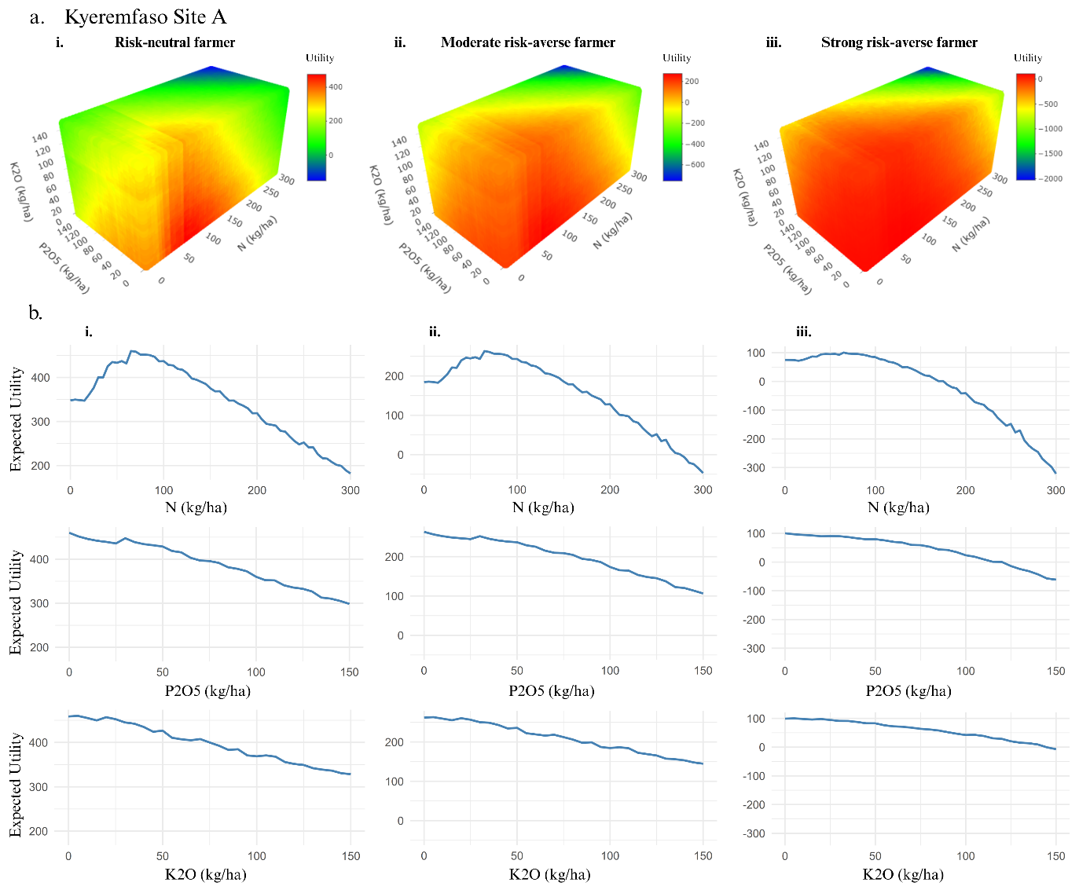

Figure SI 17: Predicted utility response to fertilizer application for different farmer risk preferences at Kyeremfaso Site A (FST zone). Panel ‘a’ shows three-dimensional utility response surfaces to N, P, and K fertilizer rates for three categories of farmer risk preference: i) Risk-neutral farmer, ii) Moderately risk-averse farmer, iii) Strongly risk-averse farmer. Colour gradients represent the magnitude of utility, with green to red indicating higher to lower utility, and blue denoting negative utility outcomes. Panel ‘b’ presents utility curves for each fertilizer nutrient: Rows represent nutrient types: top = N, middle = P, bottom = K. Columns correspond to the same risk profiles as in Panel ‘a’: i) Risk-neutral, ii) Moderate risk-averse, iii) Strong risk-averse farmers.

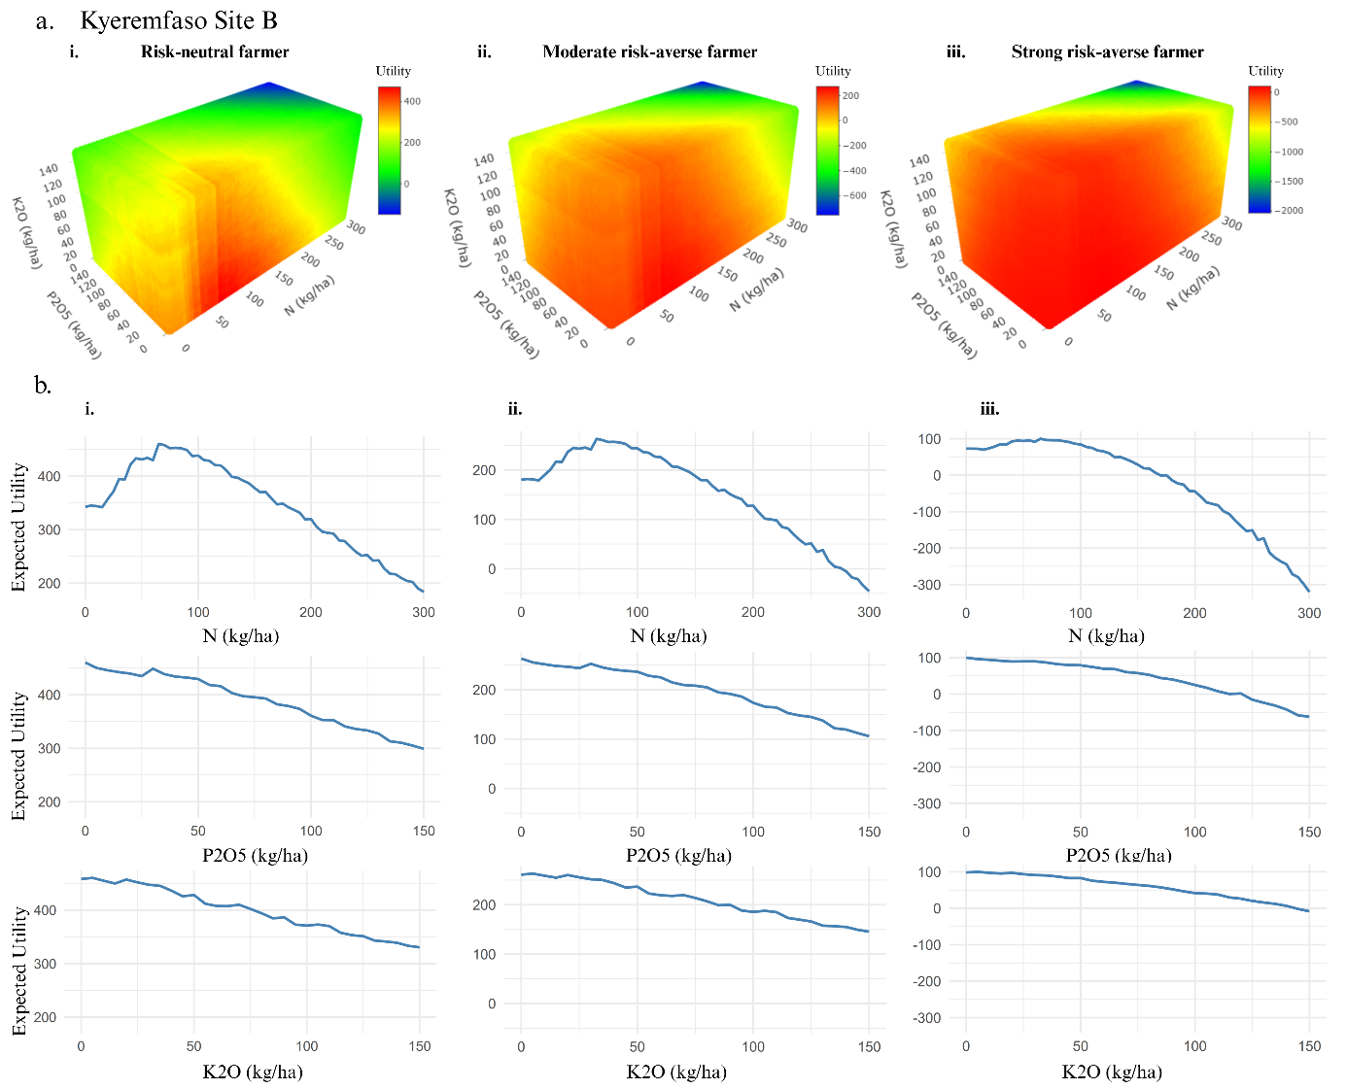

Figure SI 18: Predicted utility response to fertilizer application for different farmer risk preferences at Kyeremfaso Site B (FST zone). Panel ‘a’ shows three-dimensional utility response surfaces to N, P, and K fertilizer rates for three categories of farmer risk preference: i) Risk-neutral farmer, ii) Moderately risk-averse farmer, iii) Strongly risk-averse farmer. Colour gradients represent the magnitude of utility, with green to red indicating higher to lower utility, and blue denoting negative utility outcomes. Panel ‘b’ presents utility curves for each fertilizer nutrient: Rows represent nutrient types: top = N, middle = P, bottom = K. Columns correspond to the same risk profiles as in Panel ‘a’: i) Risk-neutral, ii) Moderate risk-averse, iii) Strong risk-averse farmers.

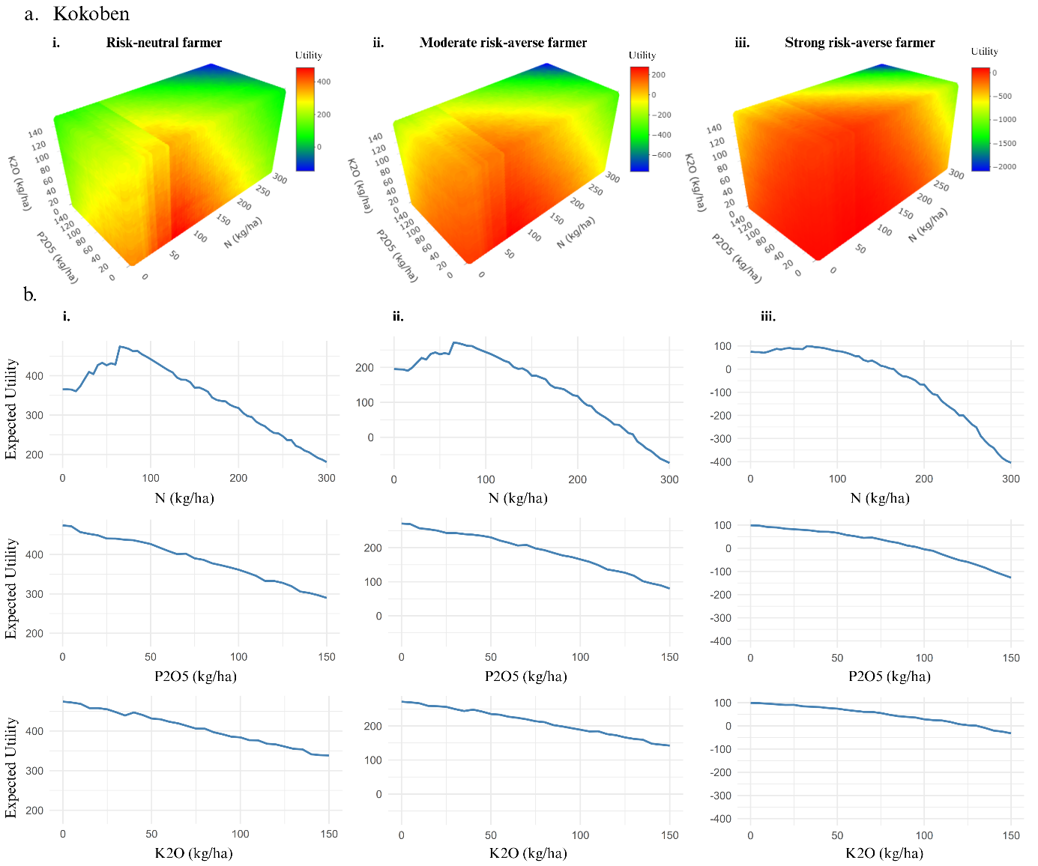

Figure SI 19: Predicted utility response to fertilizer application for different farmer risk preferences at Kokoben (SDF zone). Panel ‘a’ shows three-dimensional utility response surfaces to N, P, and K fertilizer rates for three categories of farmer risk preference: i) Risk-neutral farmer, ii) Moderately risk-averse farmer, iii) Strongly risk-averse farmer. Colour gradients represent the magnitude of utility, with green to red indicating higher to lower utility, and blue denoting negative utility outcomes. Panel ‘b’ presents utility curves for each fertilizer nutrient: Rows represent nutrient types: top = N, middle = P, bottom = K. Columns correspond to the same risk profiles as in Panel ‘a’: i) Risk-neutral, ii) Moderate risk-averse, iii) Strong risk-averse farmers.

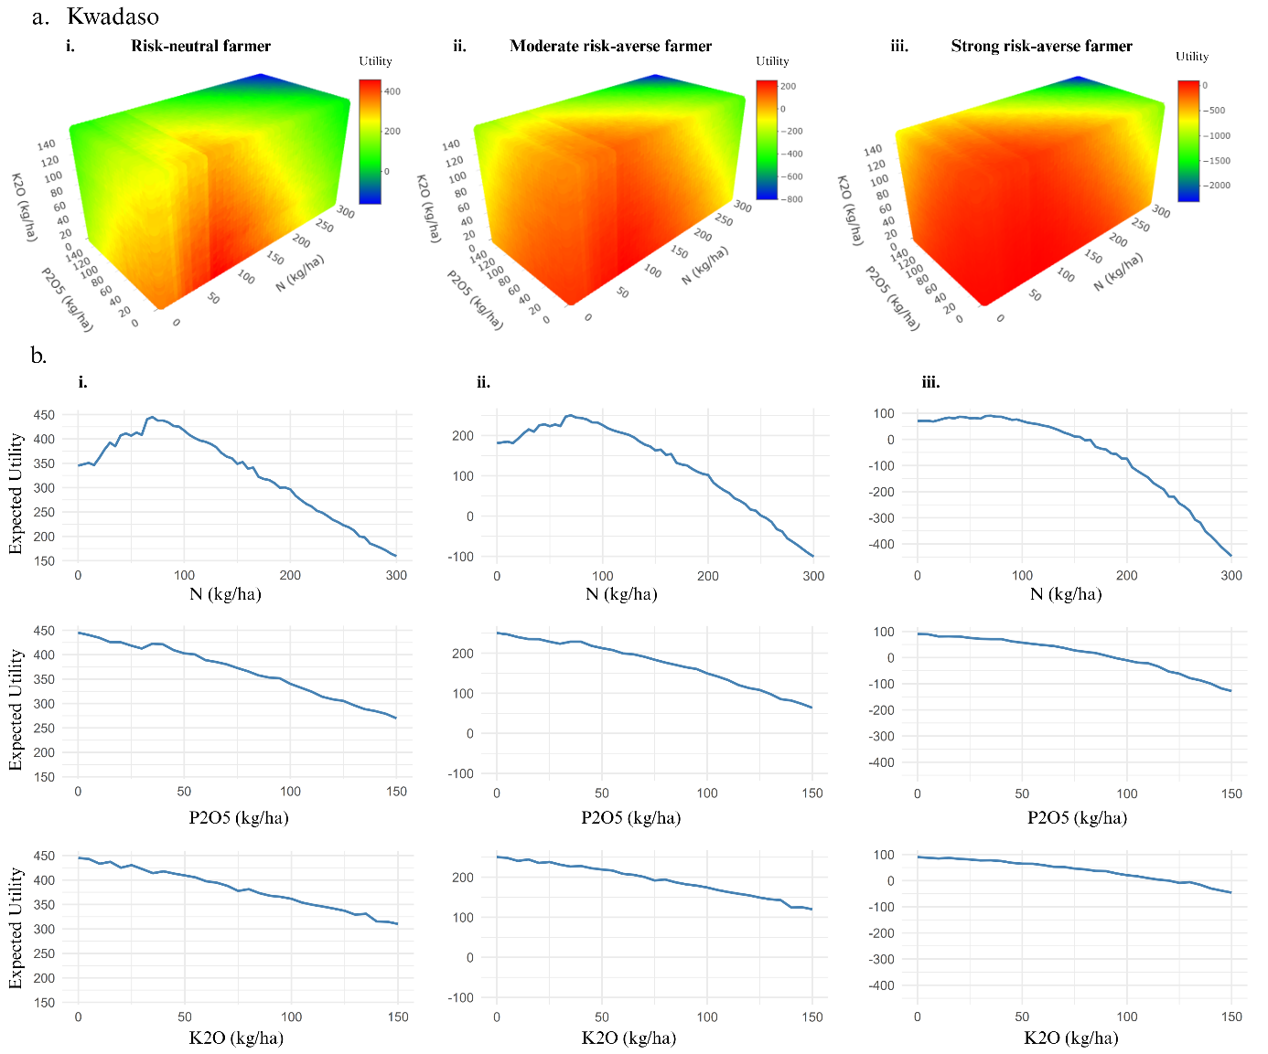

Figure SI 20: Predicted utility response to fertilizer application for different farmer risk preferences at Kwadaso (SDF zone). Panel ‘a’ shows three-dimensional utility response surfaces to N, P, and K fertilizer rates for three categories of farmer risk preference: i) Risk-neutral farmer, ii) Moderately risk-averse farmer, iii) Strongly risk-averse farmer. Colour gradients represent the magnitude of utility, with green to red indicating higher to lower utility, and blue denoting negative utility outcomes. Panel ‘b’ presents utility curves for each fertilizer nutrient Rows represent nutrient types: top = N, middle = P, bottom = K. Columns correspond to the same risk profiles as in Panel ‘a’: i) Risk-neutral, ii) Moderate risk-averse, iii) Strong risk-averse farmers.

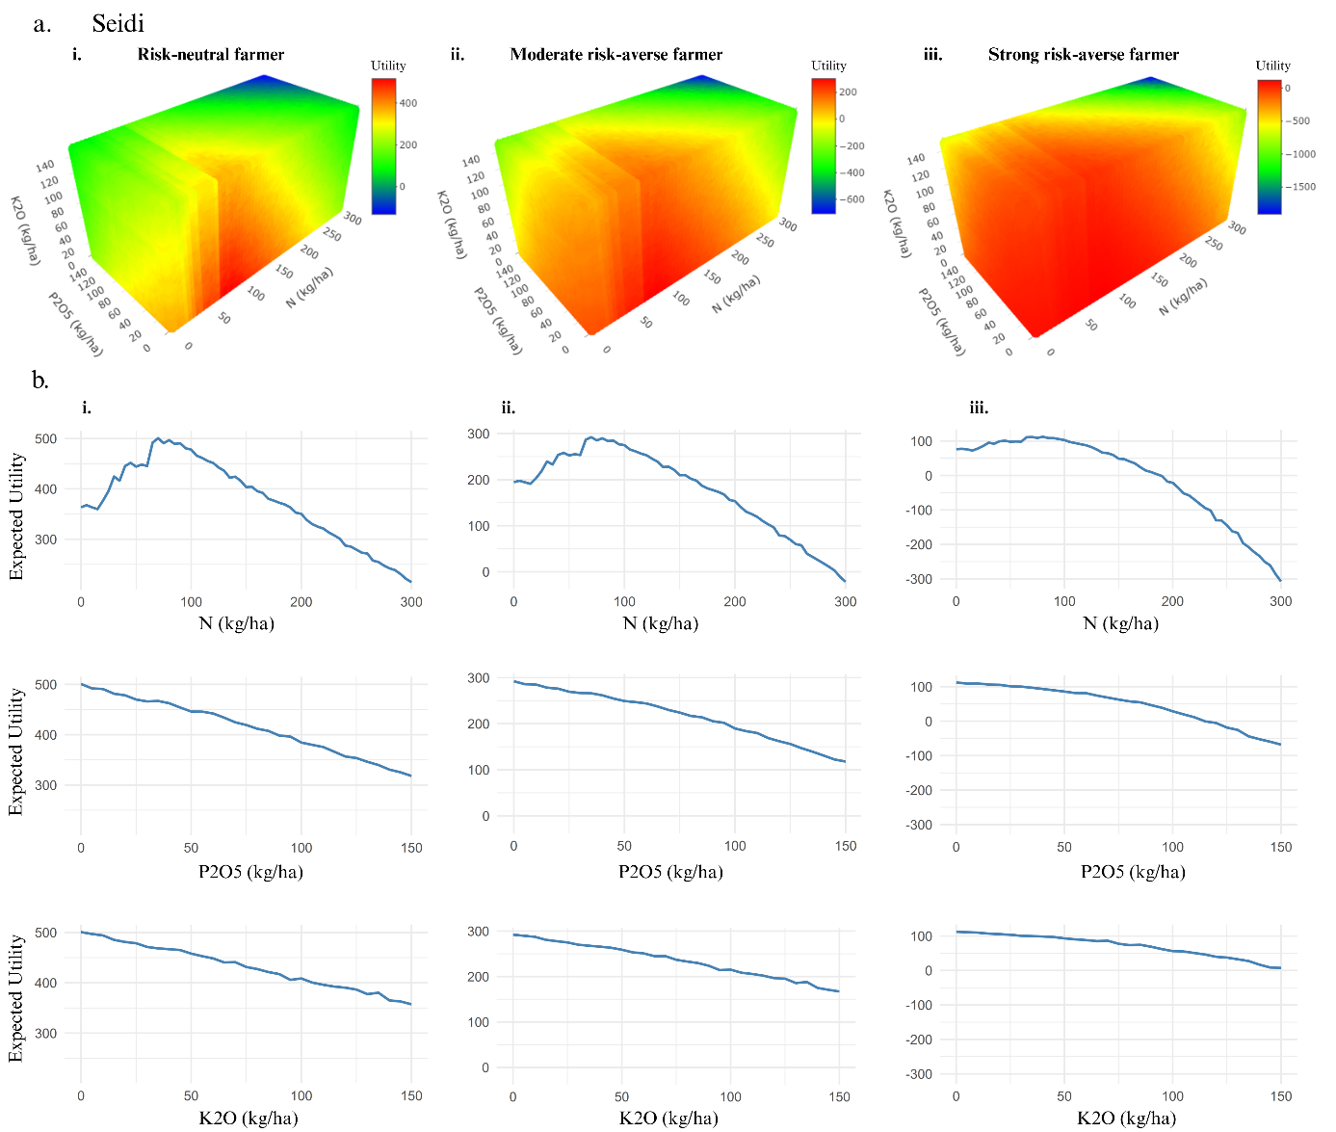

Figure SI 21: Predicted utility response to fertilizer application for different farmer risk preferences at Seidi (SDF zone). Panel ‘a’ shows three-dimensional utility response surfaces to N, P, and K fertilizer rates for three categories of farmer risk preference: i) Risk-neutral farmer, ii) Moderately risk-averse farmer, iii) Strongly risk-averse farmer. Colour gradients represent the magnitude of utility, with green to red indicating higher to lower utility, and blue denoting negative utility outcomes. Panel ‘b’ presents utility curves for each fertilizer nutrient: Rows represent nutrient types: top = N, middle = P, bottom = K. Columns correspond to the same risk profiles as in Panel ‘a’: i) Risk-neutral, ii) Moderate risk-averse, iii) Strong risk-averse farmers.

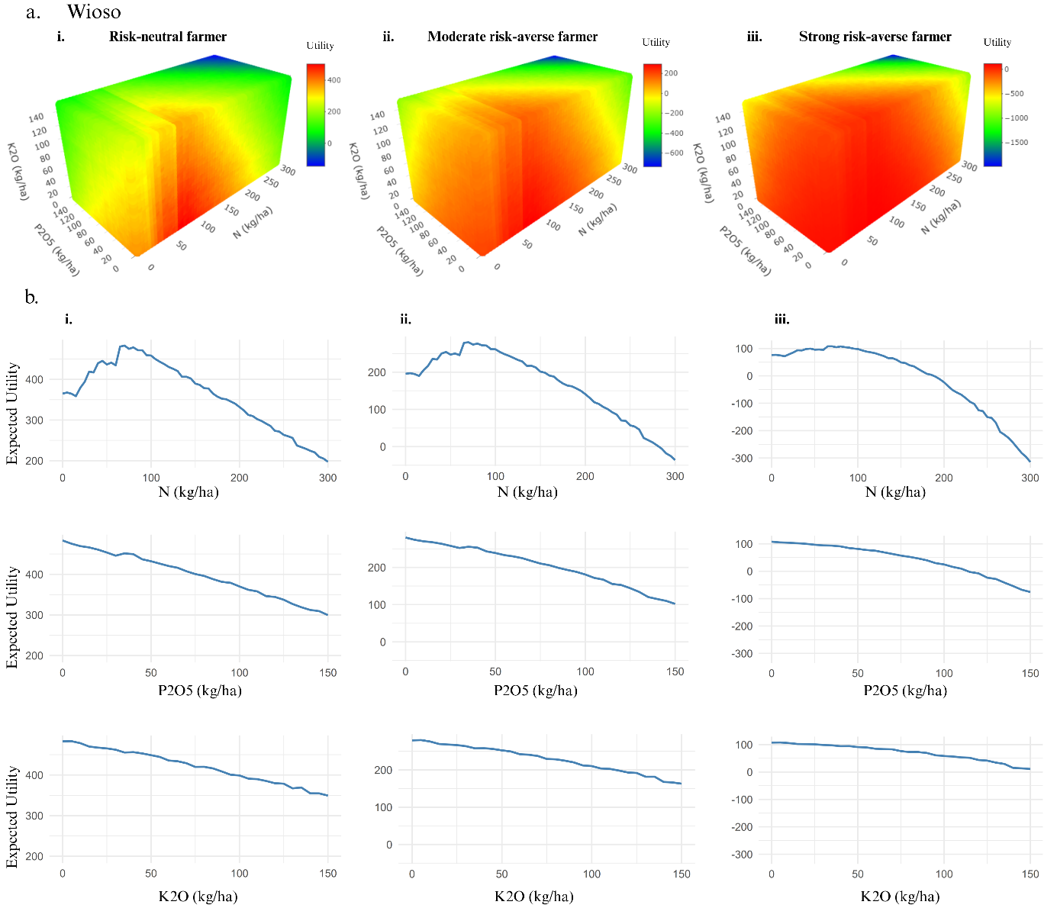

Figure SI 22: Predicted utility response to fertilizer application for different farmer risk preferences at Wioso (SDF zone). Panel ‘a’ shows three-dimensional utility response surfaces to N, P, and K fertilizer rates for three categories of farmer risk preference: i) Risk-neutral farmer, ii) Moderately risk-averse farmer, iii) Strongly risk-averse farmer. Colour gradients represent the magnitude of utility, with green to red indicating higher to lower utility, and blue denoting negative utility outcomes. Panel ‘b’ presents utility curves for each fertilizer nutrient: Rows represent nutrient types: top = N, middle = P, bottom = K. Columns correspond to the same risk profiles as in Panel ‘a’: i) Risk-neutral, ii) Moderate risk-averse, iii) Strong risk-averse farmers.

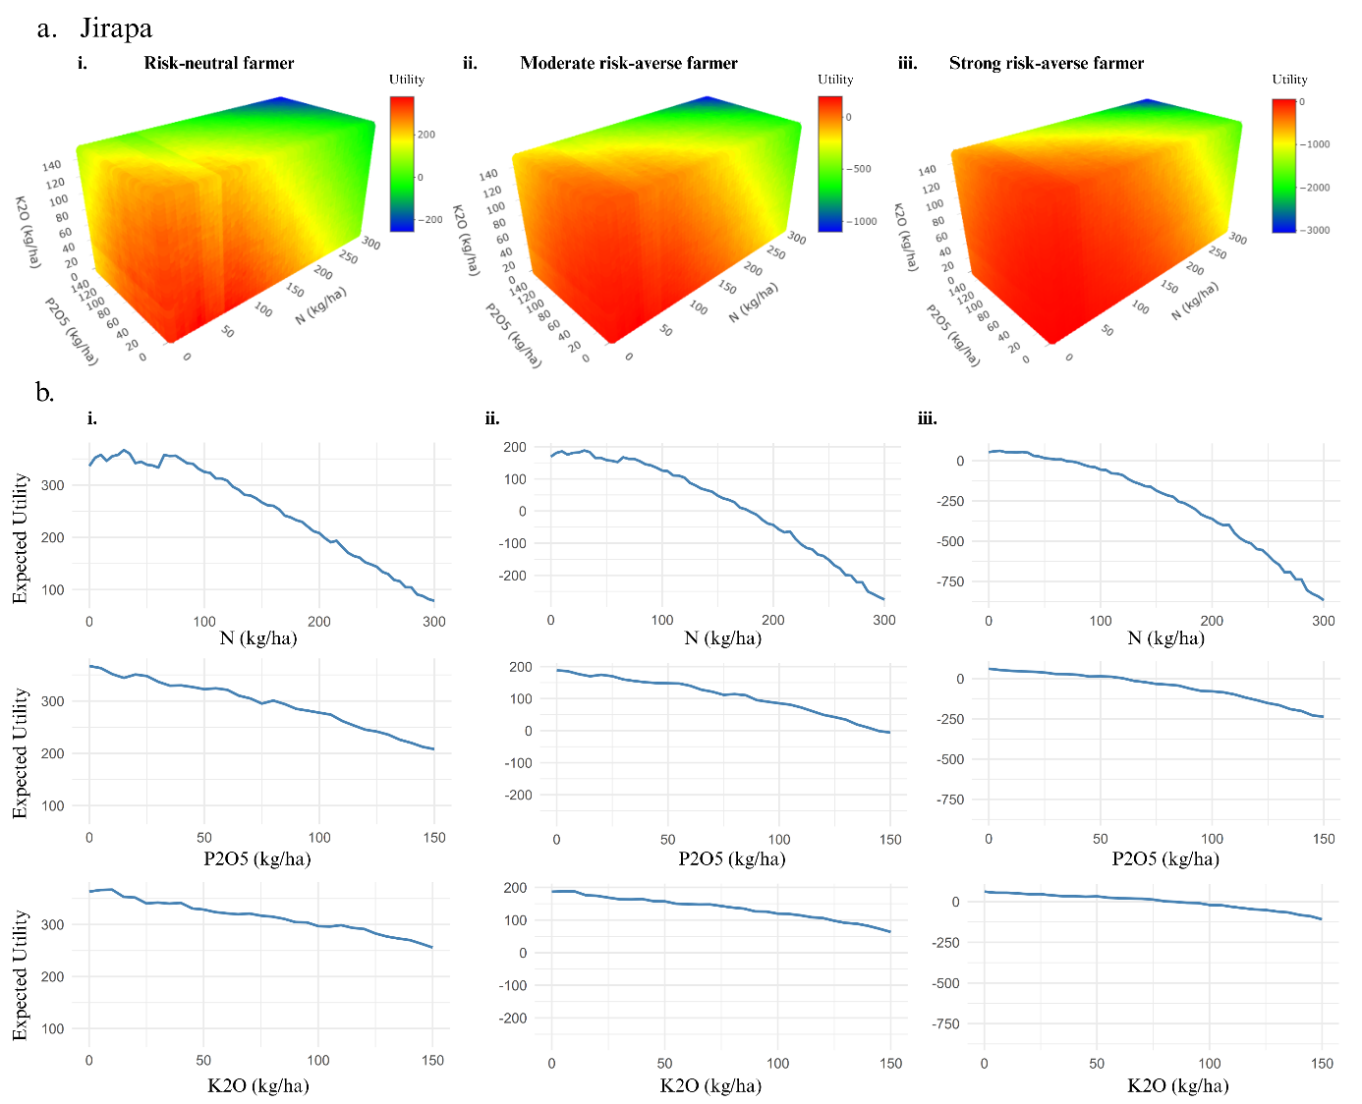

Figure SI 23: Predicted utility response to fertilizer application for different farmer risk preferences at Jirapa (GS zone). Panel ‘a’ shows three-dimensional utility response surfaces to N, P, and K fertilizer rates for three categories of farmer risk preference: i) Risk-neutral farmer, ii) Moderately risk-averse farmer, iii) Strongly risk-averse farmer. Colour gradients represent the magnitude of utility, with green to red indicating higher to lower utility, and blue denoting negative utility outcomes. Panel ‘b’ presents utility curves for each fertilizer nutrient: Rows represent nutrient types: top = N, middle = P, bottom = K. Columns correspond to the same risk profiles as in Panel ‘a’: i) Risk-neutral, ii) Moderate risk-averse, iii) Strong risk-averse farmers.

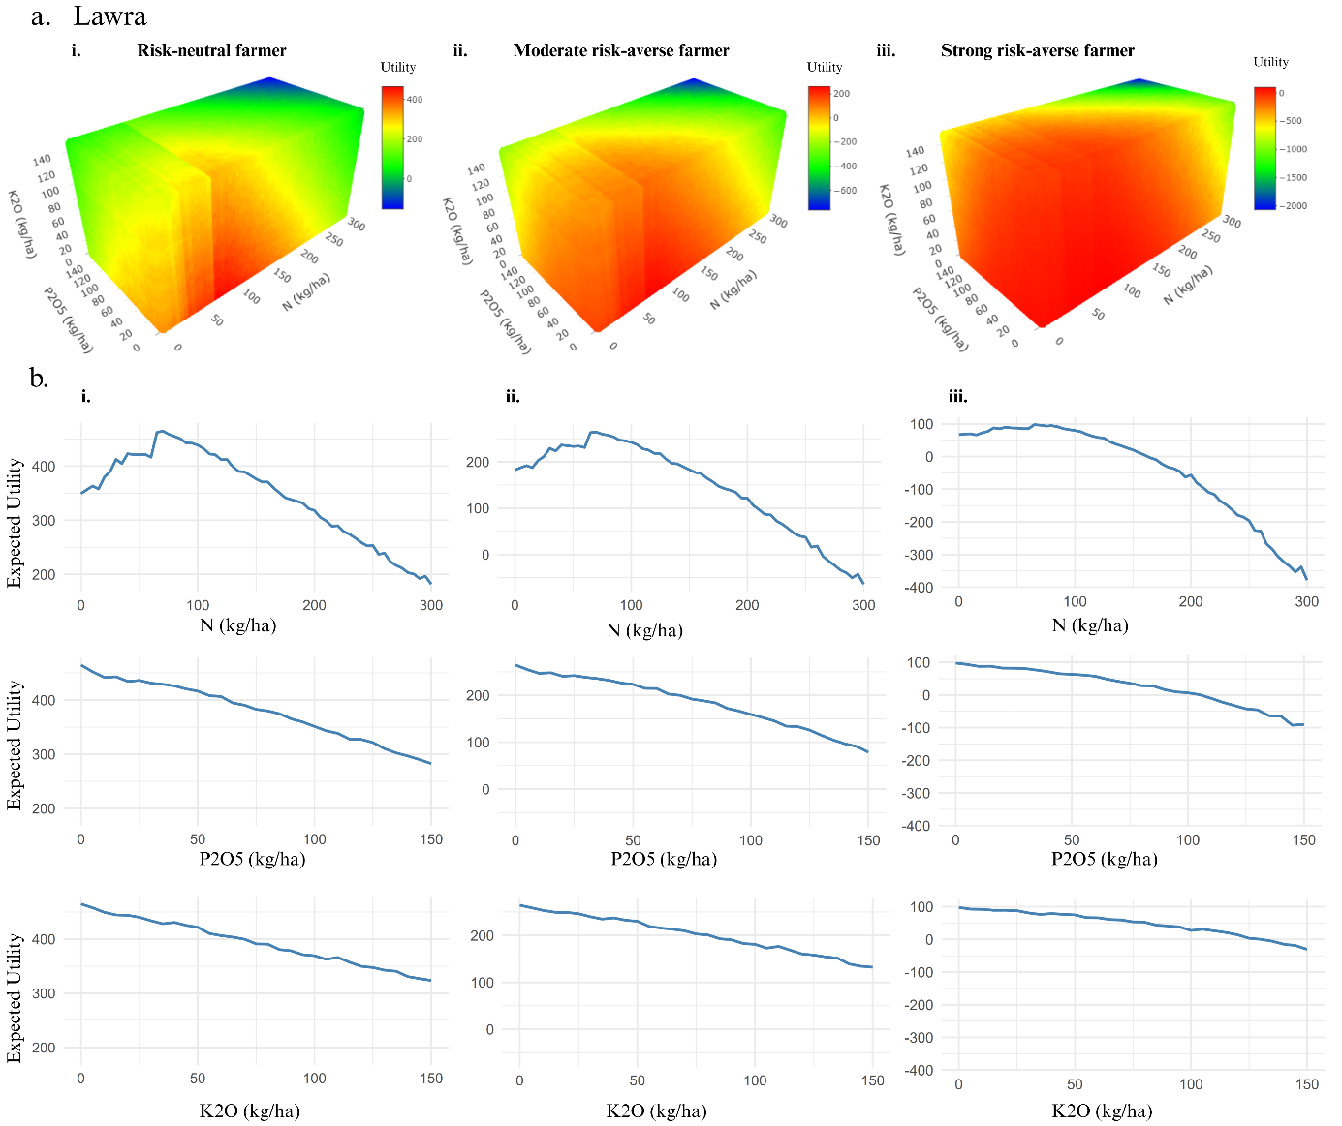

Figure SI 24: Predicted utility response to fertilizer application for different farmer risk preferences at Lawra (GS zone). Panel ‘a’ shows three-dimensional utility response surfaces to N, P, and K fertilizer rates for three categories of farmer risk preference: i) Risk-neutral farmer, ii) Moderately risk-averse farmer, iii) Strongly risk-averse farmer. Colour gradients represent the magnitude of utility, with green to red indicating higher to lower utility, and blue denoting negative utility outcomes. Panel ‘b’ presents utility curves for each fertilizer nutrient: Rows represent nutrient types: top = N, middle = P, bottom = K. Columns correspond to the same risk profiles as in Panel ‘a’: i) Risk-neutral, ii) Moderate risk-averse, iii) Strong risk-averse farmers.

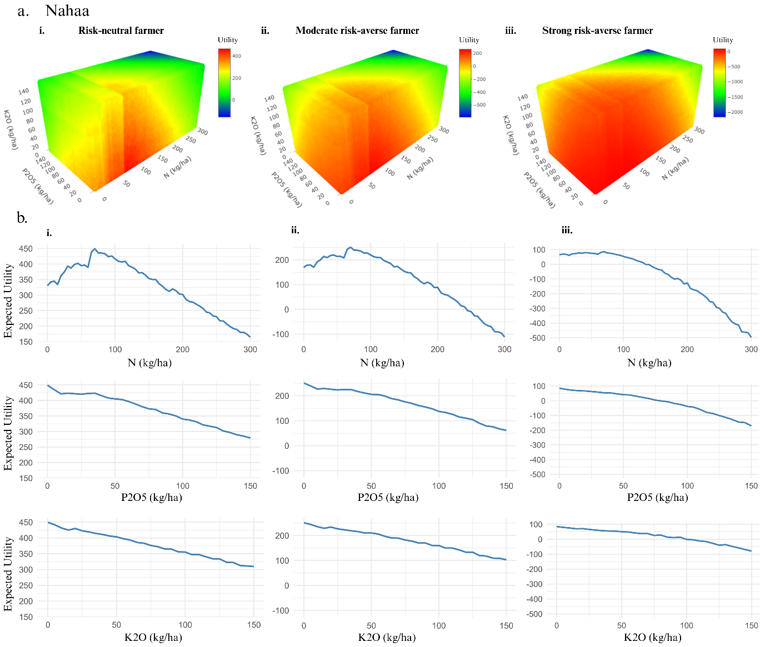

Figure SI 25: Predicted utility response to fertilizer application for different farmer risk preferences at Nahaa (GS zone). Panel ‘a’ shows three-dimensional utility response surfaces to N, P, and K fertilizer rates for three categories of farmer risk preference: i) Risk-neutral farmer, ii) Moderately risk-averse farmer, iii) Strongly risk-averse farmer. Colour gradients represent the magnitude of utility, with green to red indicating higher to lower utility, and blue denoting negative utility outcomes. Panel ‘b’ presents utility curves for each fertilizer nutrient: Rows represent nutrient types: top = N, middle = P, bottom = K. Columns correspond to the same risk profiles as in Panel ‘a’: i) Risk-neutral, ii) Moderate risk-averse, iii) Strong risk-averse farmers.

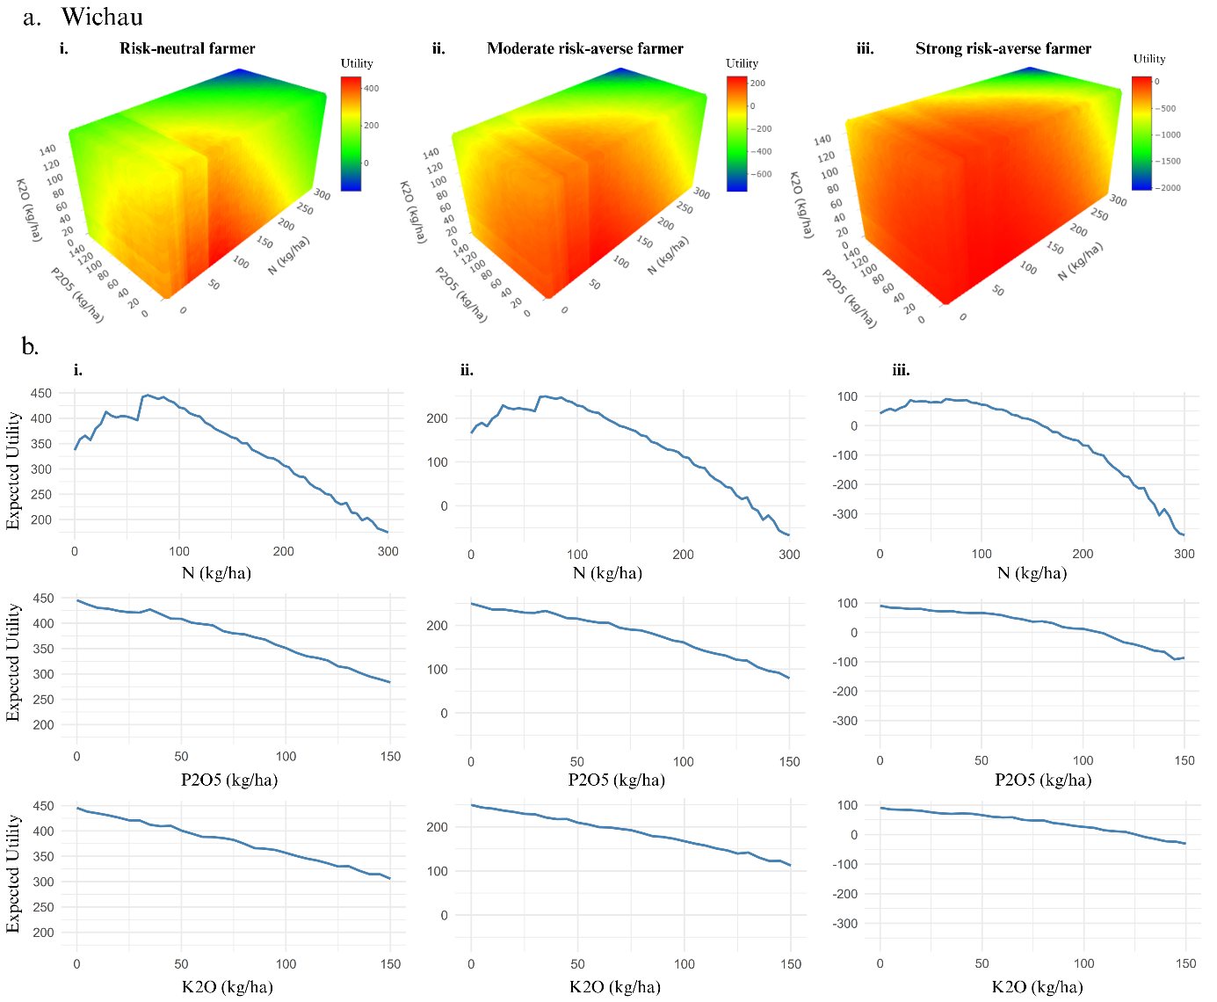

Figure SI 26: Predicted utility response to fertilizer application for different farmer risk preferences at Wichau (GS zone). Panel ‘a’ shows three-dimensional utility response surfaces to N, P, and K fertilizer rates for three categories of farmer risk preference: i) Risk-neutral farmer, ii) Moderately risk-averse farmer, iii) Strongly risk-averse farmer. Colour gradients represent the magnitude of utility, with green to red indicating higher to lower utility, and blue denoting negative utility outcomes. Panel ‘b’ presents utility curves for each fertilizer nutrient: Rows represent nutrient types: top = N, middle = P, bottom = K. Columns correspond to the same risk profiles as in Panel ‘a’: i) Risk-neutral, ii) Moderate risk-averse, iii) Strong risk-averse farmers.